For the alarm, this function needs a folder called "image" under the project path like this:

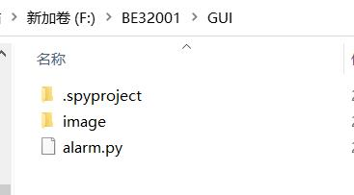

And add these picture in the “image”.

